**Test Cases:**

***Scenario 1: Basic Messaging***

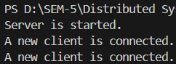

When new client is connected to server, it shows this message on server side.

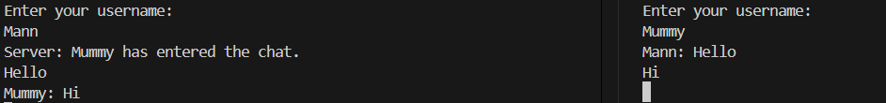

Also, it broadcasts to all other clients which join before that “`client_name` has entered the chat”. Client can send and receive messages from each other.

***Scenario 2: Client Disconnection***

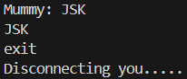 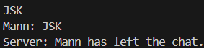

On writing command `exit`, client leave the server and it disconnected. Also, server informs all other client that “`client_name` has left the chat.”

***Scenario 3: Abrupt Disconnection***

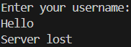

On forcefully quitting the server, all the connected client can see error message “Server lost” and disconnected.